**GUI**

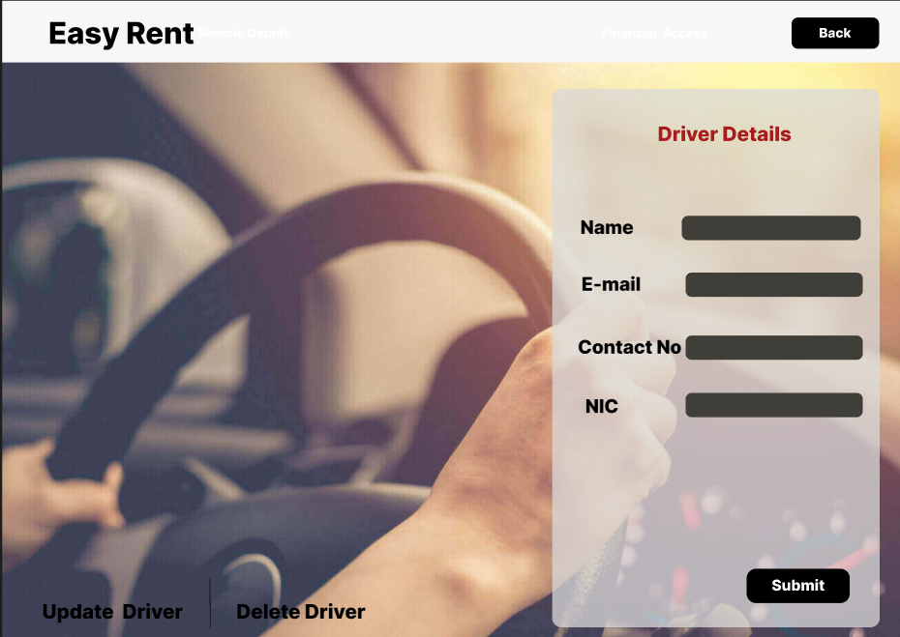

Activity Diagram

Sequence Diagram

